**Experiment No.: 1**

Create a class ‘Employee’ with data members Empid, Name, Salary, Address and

constructors to initialize the data members. Create another class ‘Teacher’ that inherit the

properties of class employee and contain its own data members department, Subjects taught

and constructors to initialize these data members and also include display function to

display all the data members. Use array of objects to display details of N teachers.

**Procedure:**

import java.util.Scanner;

class Employee { //Emp teacher single level using super

int empid;

String name;

int salary;

String address;

Employee(int a, String b, int c, String d)

{

empid = a;

name = b;

salary = c;

address = d;

}

}

class Teacher extends Employee

{

String department;

String subject;

Teacher(int l, String m, int n, String o, String p, String q)

{

super(l, m, n, o);

department = p;

subject = q;

}

public void display()

{

System.out.println("employee id is "+empid);

System.out.println("employee name is "+name);

System.out.println("Salary is "+salary);

System.out.println("Employee address is "+address);

System.out.println("Teacher department is "+department);

System.out.println("Teacher subject is "+subject);

}

}

public class Emp_teacher_single {

public static void main(String[] args) {

int i;

Scanner cin = new Scanner(System.in);

System.out.println("Enter the limit of array");

int n = cin.nextInt();

Teacher e[] = new Teacher[n];

for (i = 0; i < n; i++) {

System.out.println("Enter the eid of Employee");

int a = cin.nextInt();

System.out.println("Enter the name of Employee");

String b = cin.next();

System.out.println("Enter the salary of Employee");

int c = cin.nextInt();

System.out.println("Enter the address of Employee");

String d = cin.next();

System.out.println("Enter the department of teachers");

String q = cin.next();

System.out.println("Enter the subject of teachers");

String f = cin.next();

e[i] = new Teacher(a, b, c, d, q, f);

System.out.println("PRINTING DETAILS");

e[i].display();

}

}

}

**Output:**

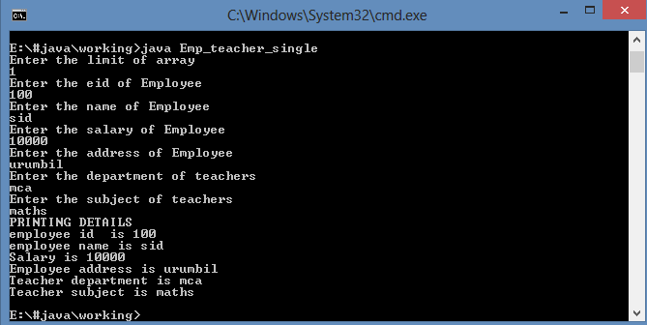

**Experiment No.: 2**

Create a class ‘Person’ with data members Name, Gender, Address, Age and a constructor

to initialize the data members and another class ‘Employee’ that inherits the properties of

class Person and also contains its own data members like Empid, Company_name,

Qualification, Salary and its own constructor. Create another class ‘Teacher’ that inherits

the properties of class Employee and contains its own data members like Subject,

Department, Teacherid and also contain constructors and methods to display the data

members. Use array of objects to display details of N teachers.

**Procedure:**

import java.util.*;

class Person { //multilevel without using super

String name;

String gender;

String address;

int age;

Person() {

Scanner sc=new Scanner(System.in);

System.out.print("Enter name of person: ");

name=sc.nextLine();

System.out.print("Enter the gender of person: ");

gender=sc.nextLine();

System.out.print("Enter the address of person: ");

address=sc.nextLine();

System.out.print("Enter the age of person: ");

age=sc.nextInt();

}

}

class Employee extends Person {

int empid;

String companyname;

String qualification;

int salary;

Employee() {

Scanner sc=new Scanner(System.in);

System.out.print("Enter the empid: ");

empid=sc.nextInt();

System.out.print("Enter the company name: ");

companyname=sc.next();

System.out.print("Enter the qualification of employee: ");

qualification=sc.next();

System.out.print("Enter the salary of employee: ");

salary=sc.nextInt();

}

}

class Teacher extends Employee {

String subject;

String department;

int teacherid;

Teacher() {

Scanner sc=new Scanner(System.in);

System.out.print("Enter the subject of teacher ");

subject=sc.nextLine();

System.out.print("Enter the department of teacher ");

department=sc.nextLine();

System.out.print("Enter the teacher id ");

teacherid=sc.nextInt();

}

void put() {

System.out.println("Person name is: "+name);

System.out.println("person gender is: "+gender);

System.out.println("person address is: "+address);

System.out.println("person age is: "+age);

System.out.println("employee id is: "+empid);

System.out.println("employee company is: "+companyname);

System.out.println("employee qualification is: "+qualification);

System.out.println("employee salary is: "+salary);

System.out.println("teacher subject is: "+subject);

System.out.println("teacher department is: "+department);

System.out.println("teacher id is: "+teacherid);

}

}

public class personmulti{

public static void main(String args[]) {

Scanner sc =new Scanner(System.in);

int i,n;

System.out.println("How many records you want to insert: ");

n=sc.nextInt();

Teacher obj[]=new Teacher[n];

System.out.println("enter the details of"+n+" records");

for (i=0;i<n;i++)

{

obj[i]=new Teacher();

}

for(i=0;i<n;i++)

{

obj[i].put();

}

}

}

**Output:**

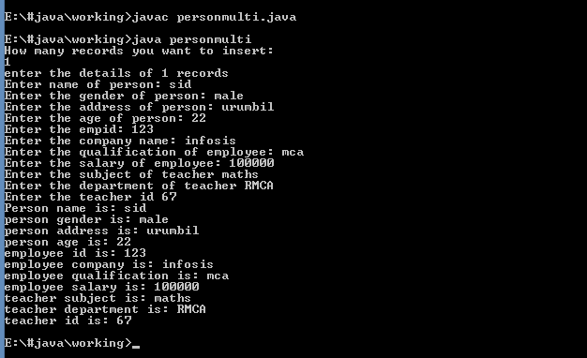

**Experiment No.: 3**

Program using overloaded function to find the largest of

a)two numbers

b)three numbers

**Procedure:**

import java.util.Scanner;

public class Largest2

{

public void largest(int a,int b)

{

int x=a;

int y=b;

if(x>y)

{

System.out.println(x+" is greater of two numbers");

}

else

{

System.out.println(y+" is greater of two numbers");

}

}

public void largest(int a,int b,int c)

{

int x=a;

int y=b;

int z=c;

if(x>y && x>z)

{

System.out.println(x+" is greater of three numbers");

}

else if(y>x && y>z)

{

System.out.println(y+" is greater of three numbers");

}

else

{

System.out.println(z+" is greater of three numbers");

}

}

public static void main(String[] args)

{

Scanner cin=new Scanner(System.in);

System.out.println("Enter first number");

int a=cin.nextInt();

System.out.println("Enter second number");

int b=cin.nextInt();

System.out.println("Enter third number");

int c=cin.nextInt();

Largest2 l=new Largest2();

l.largest(a,b);

l.largest(a,b,c);

}

}

**Output:**

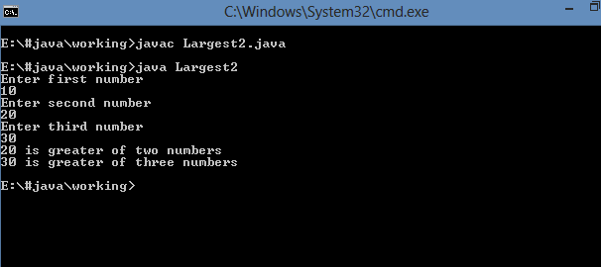

**Experiment No.: 4**

Program using overloaded function to perform different types of sum such as

a)sum of two numbers

b)sum of digits of a number

c)sum of 2 strings

**Procedure:**

public class Sumeg

{

public static int sum(int a, int b)

{

return a + b;

}

public static int sum(int n)

{

int sum = 0;

while (n > 0)

{

sum =sum+n%10;

n=n/10;

}

return sum;

}

public static String sum(String s1, String s2)

{

return s1 + s2;

}

public static void main(String[] args) {

System.out.println(sum(5, 10));

System.out.println(sum(123));

System.out.println(sum("Hello","Sid"));

}

}

**Output:**

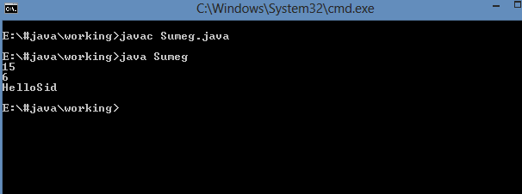

**Experiment No.: 5**

Overload a function ‘average’ to find average of two integers, two double values and three float values.

**Procedure:**

public class Avgeg{

public static double average(int num1, int num2) {

return (num1 + num2) / 2;

}

public static double average(double num1, double num2) {

return (num1 + num2) / 2.0;

}

public static float average(float num1, float num2, float num3) {

return (num1 + num2 + num3) / 3.0f;

}

public static void main(String[] args) {

int num1 = 10;

int num2 = 20;

double num3 = 3.14;

double num4 = 6.28;

float num5 = 1.2f;

float num6 = 2.4f;

float num7 = 3.6f;

System.out.println("Average of " + num1 + " and " + num2 + " is " + average(num1, num2));

System.out.println("Average of " + num3 + " and " + num4 + " is " + average(num3, num4));

System.out.println("Average of " + num5 + ", " + num6 + " and " + num7 + " is " + average(num5, num6, num7));

}

}

**Output:**

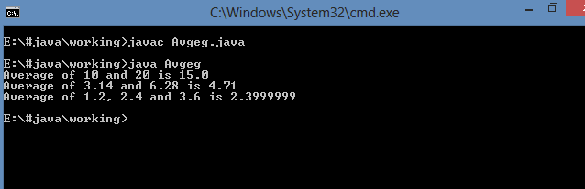

**Experiment No.: 6**

Function overloading program to overload method volume of cuboid,cube,cylinder and sphere .

**Procedure:**

public class Shapev {

public double volume(double length, double width, double height) //cuboid

{

return length * width * height;

}

public double volume(double side) //cube

{

return side * side * side;

}

public double volume(double radius, double height) //cylinder

{

return 3.14 * radius * radius * height;

}

public float volume(float radius) //sphere

{

return (4.0f/3.0f) *3.14f * radius * radius * radius;

}

public static void main(String[] args) {

Shapev s = new Shapev();

System.out.println("Volume of a cuboid with length 2, width 3, and height 4 is: " + s.volume(2, 3, 4));

System.out.println("Volume of a cube with side 5 is: " + s.volume(5));

System.out.println("Volume of a cylinder with radius 2 and height 6 is: " + s.volume(2, 6));

System.out.println("Volume of a sphere with radius 3 is: " + s.volume(3.5f));

}

}

**Output:**

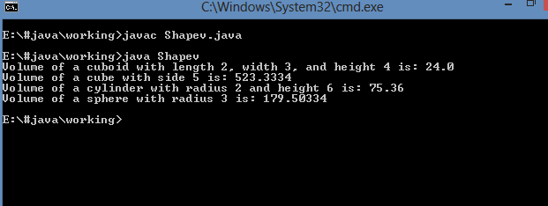

**Experiment No.: 7**

Function overloading program to overload method area of circle,triangle,square and rectangle .

**Procedure:**

public class Shapea {

//circle

public static double area(double radius) {

return 3.14 * radius * radius;

}

//triangle

public static double area(double base, double height) {

return 0.5 * base * height;

}

//square

public static double area(float side) {

return side * side;

}

//rectangle

public static double area(double length, float breadth) {

return length * breadth;

}

public static void main(String[] args) {

System.out.println("Area of Circle: " + area(5.5));

System.out.println("Area of Triangle: " + area(5, 10));

System.out.println("Area of Square: " + area(5.5));

System.out.println("Area of Rectangle: " + area(5, 10.5f));

}

}

**Output:**

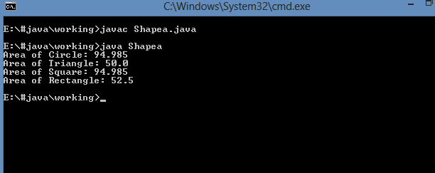

**Experiment No.: 8**

Program to define a class ‘student’ having data members rollno, name. Derive a class ‘marks’ from ‘student’ having data members m1, m2, m3, total and percentage. Accept and display data of one student.

.

**Procedure:**

import java.util.*;

class Student

{

int rollno;

String name;

Student()

{

Scanner sc = new Scanner(System.in);

System.out.print("Enter rollno of student:");

rollno = sc.nextInt();

System.out.print("Enter Name of student :");

name = sc.next();

}

}

class Marks extends Student

{

double m1,m2,m3,t;

Marks()

{

Scanner sc = new Scanner(System.in);

System.out.print("Enter Mark1 out of 50 :");

m1 = sc.nextDouble();

System.out.print("Enter Mark2 out of 50 :");

m2 = sc.nextDouble();

System.out.print("Enter Mark3 out of 50 :");

m3 = sc.nextDouble();

}

void total()

{

double total,per;

total= m1+m2+m3;

per = (total/150)*100;

System.out.println("Rollno :"+rollno);

System.out.println("Name :"+name);

System.out.println("Total mark obtained :"+total);

System.out.println("Total percentage obtained :"+per);

}

}

class prgm8

{

public static void main(String args[])

{

Marks obj = new Marks();

obj.total();

}

}

**Output:**

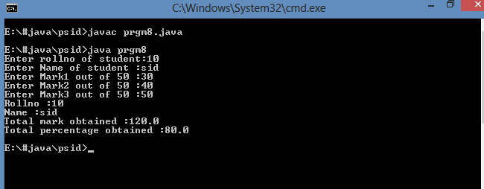

**Experiment No.: 9**

Program define a class ‘employee’ having data members emp_id, emp_name and emp_designation. Derive a class ‘salary’ from ‘employee’ having data members basic, HRA, DA, gross_salary. Accept and display data of one employee.

DA=basic*35/100

HRA=basic*15/100

GS=basic+DA+HRA

.

**Procedure:**

import java.util.*;

class Employee

{

int empid;

String name;

String des;

Employee()

{

Scanner sc = new Scanner(System.in);

System.out.print("Enter Emp id of employee:");

empid = sc.nextInt();

System.out.print("Enter Name of employee :");

name = sc.next();

System.out.print("Enter designation of employee:");

des = sc.next();

}

}

class Salary extends Employee

{

double b,hra,da,gross;

Salary()

{

Scanner sc = new Scanner(System.in);

System.out.print("Enter Basic pay of employee :");

b = sc.nextDouble();

da =b*35/100;

hra = b*15/100;

gross = b+da+hra;

}

void display()

{

System.out.println("Emp id is :"+empid);

System.out.println("Emp name is:"+name);

System.out.println("Emp designation is:"+des);

System.out.println("DA is:"+da);

System.out.println("hra is:"+hra);

System.out.println("Emp gross is:"+gross);

}

}

class prgm9

{

public static void main(String args[])

{

Salary obj = new Salary();

obj.display();

}

}

**Output:**

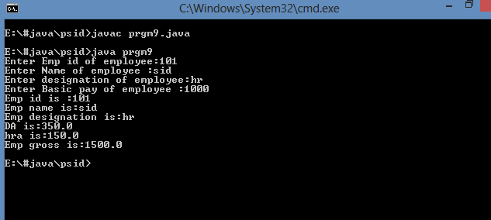

**Experiment No.: 10**

Declare a class ‘box’ having data members length, width and height. Derive a class ‘cupboard’ from ‘box’ having data members no of shelves. Write a program to accept and display this data for one cupboard object.

.

**Procedure:**

import java.util.*;

class Box

{

int length,width,height;

Box()

{

Scanner sc = new Scanner(System.in);

System.out.print("Enter length of box:");

length = sc.nextInt();

System.out.print("Enter width of box:");

width = sc.nextInt();

System.out.print("Enter height of box:");

height = sc.nextInt();

}

}

class Cupboard extends Box

{

int shelves;

Cupboard()

{

Scanner sc = new Scanner(System.in);

System.out.print("Enter no of shelves:");

shelves = sc.nextInt();

}

void display()

{

System.out.println("length of box is :"+length);

System.out.println("width od box is:"+width);

System.out.println("height of box is:"+height);

System.out.println("no of shelves is:"+shelves);

}

}

class prgm10

{

public static void main(String args[])

{

Cupboard obj = new Cupboard();

obj.display();

}

}

**Output:**

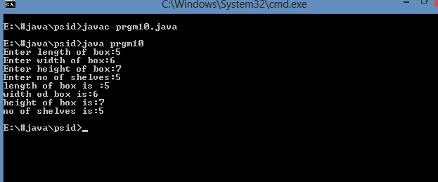

**Experiment No.: 11**

Program to define a class ‘employee’ having data members emp_id and emp_name. Derive a class ‘worker’ from ‘employee’ having data members daily_wages. Accept and display data of one worker.

**Procedure:**

import java.util.*;

class Employee

{

int empid;

String name;

Employee()

{

Scanner sc = new Scanner(System.in);

System.out.print("Enter Emp id of employee :");

empid = sc.nextInt();

System.out.print("Enter Name of employee:");

name = sc.next();

}

}

class Worker extends Employee

{

int wage;

Worker()

{

Scanner sc = new Scanner(System.in);

System.out.print("Enter Daily Wage of employee :");

wage = sc.nextInt();

}

void display()

{

System.out.println("Emp id is:"+empid);

System.out.println("Emp name is:"+name);

System.out.println("Emp wage is:"+wage);

}

}

class prgm11

{

public static void main(String args[])

{

Worker obj = new Worker();

obj.display();

}

}

**Output:**

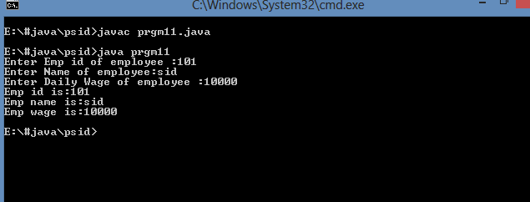

**Experiment No.: 12**

Program to find the total marks obtained and percentage scored by a student.

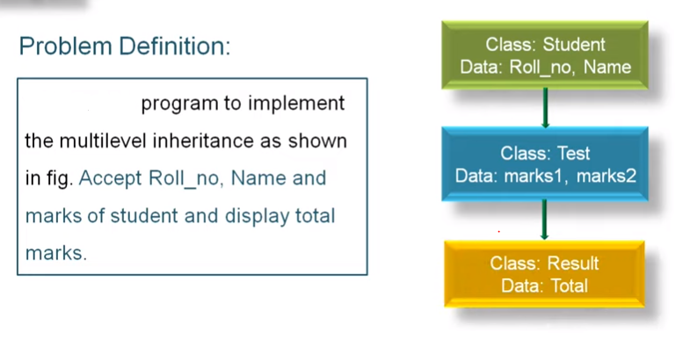

**Procedure:**

import java.util.*;

class Student

{

int rollno;

String name;

Student()

{

Scanner sc = new Scanner(System.in);

System.out.print("Enter rollno of student :");

rollno = sc.nextInt();

System.out.print("Enter Name of studdent:");

name = sc.next();

}

}

class Test extends Student

{

double mark1;

double mark2;

Test()

{

Scanner sc = new Scanner(System.in);

System.out.print("Enter mark1 out of 50 :");

mark1 = sc.nextDouble();

System.out.print("Enter mark2 out of 50:");

mark2 = sc.nextDouble();

}

}

class Result extends Test

{

void total()

{

double per,total;

total = mark1+mark2;

per=(total/100)*100;

System.out.println("Rollno :"+rollno);

System.out.println("Name :"+name);

System.out.println("Total mark obtained :"+total);

System.out.println("Percentage obtained is:"+per);

}

}

class prgm12

{

public static void main(String args[])

{

Result obj = new Result();

obj.total();

}

}

**Output:**

